AD23532 – PRINCIPLES OF DATA SCIENCE
EXPERIMENT 6A: EXPLORATORY DATA ANALYSIS

QUESTION:
Perform Exploratory Data Analysis (EDA) on the Netflix Titles dataset to analyze content distribution, release trends, duration, genres, directors, actors, countries, ratings, and descriptions. Use statistical analysis and visualizations to identify patterns and insights in Netflix movies and TV shows.

AIM:
To perform Exploratory Data Analysis on the Netflix Titles dataset using Python by examining content types, ratings, release years, countries, durations, genres, directors, actors, and textual descriptions, and visualizing the findings using suitable graphs and charts.

ALGORITHM:
- Import the required Python libraries: Pandas, NumPy, Matplotlib, Seaborn, and WordCloud.
- Load the Netflix Titles dataset into a Pandas DataFrame and examine its shape, columns, data types, missing values, and summary statistics.
- Analyze the distribution of Movies and TV Shows, content ratings, and countries using count plots and bar charts.
- Analyze release years and date-added trends to identify the years with the highest content releases and Netflix content growth.
- Examine movie durations and TV show seasons using histograms and bar charts.
- Identify the top 10 genres, directors, and actors appearing most frequently on Netflix.
- Generate a word cloud to identify common words in content descriptions.
- Analyze monthly content additions, compare movie and TV show production by country, and examine ratings across content types.
- Identify the oldest and newest titles and create a genre co-occurrence heatmap to study relationships between genres.
- Interpret the visualizations and summarize the major findings from the dataset.

PROGRAM & OUTPUT:
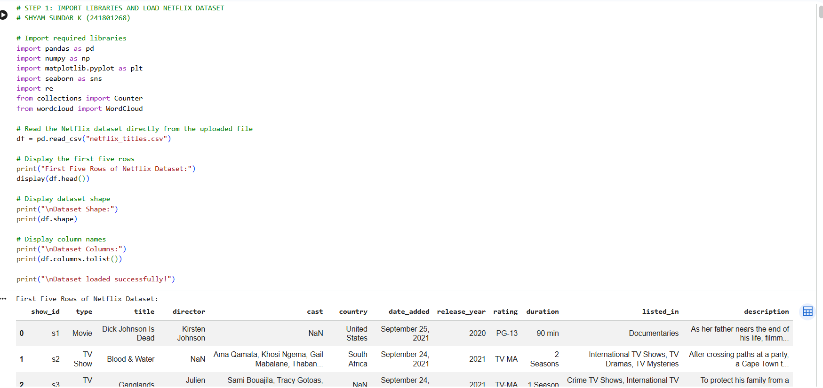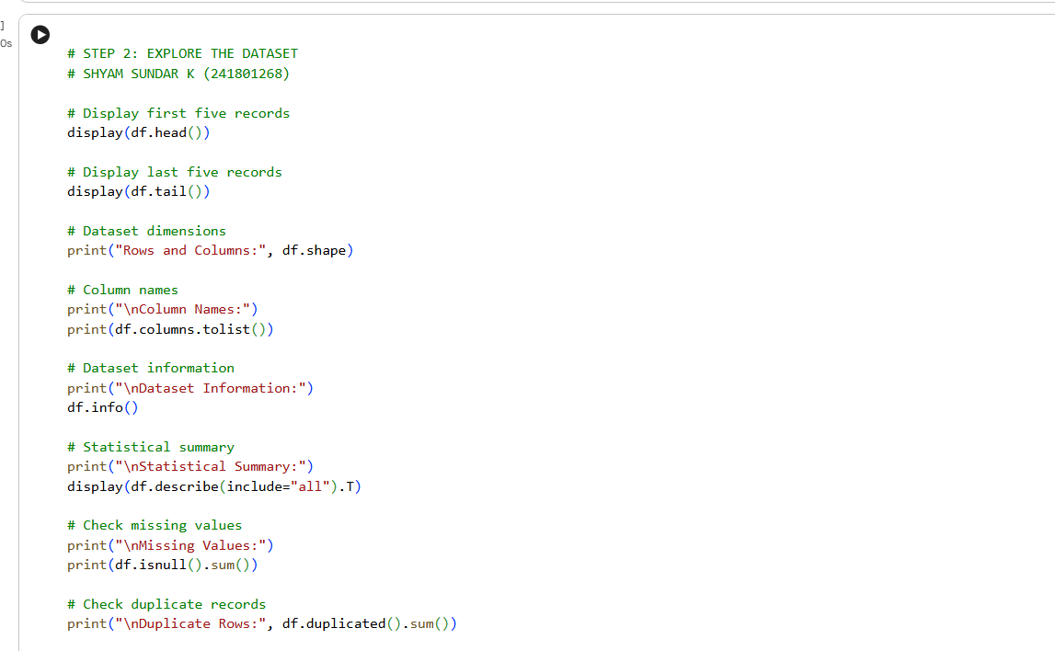
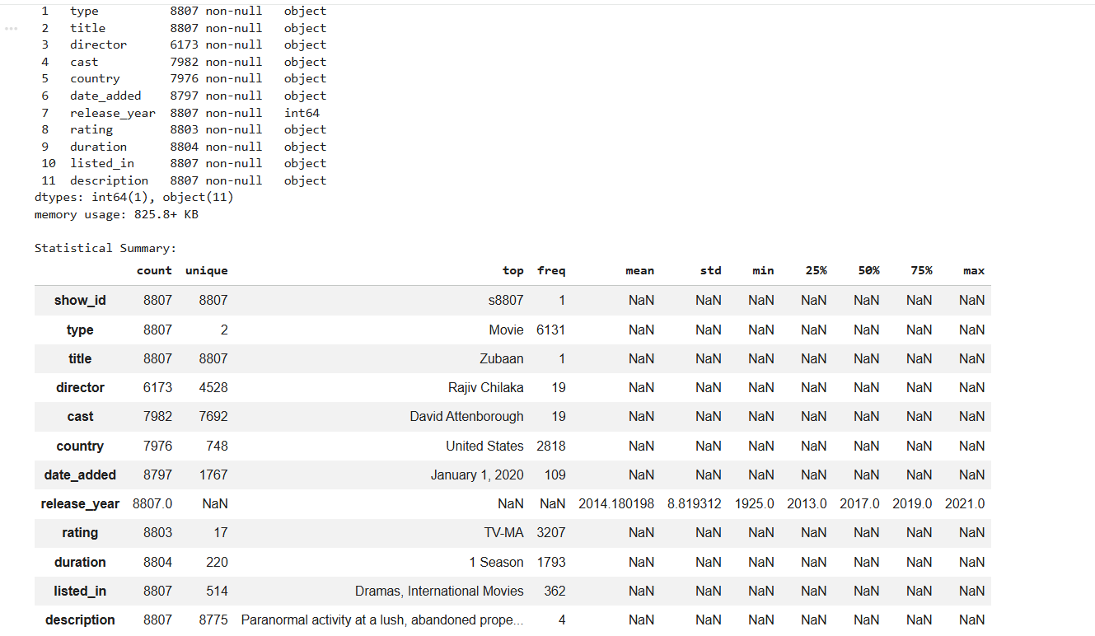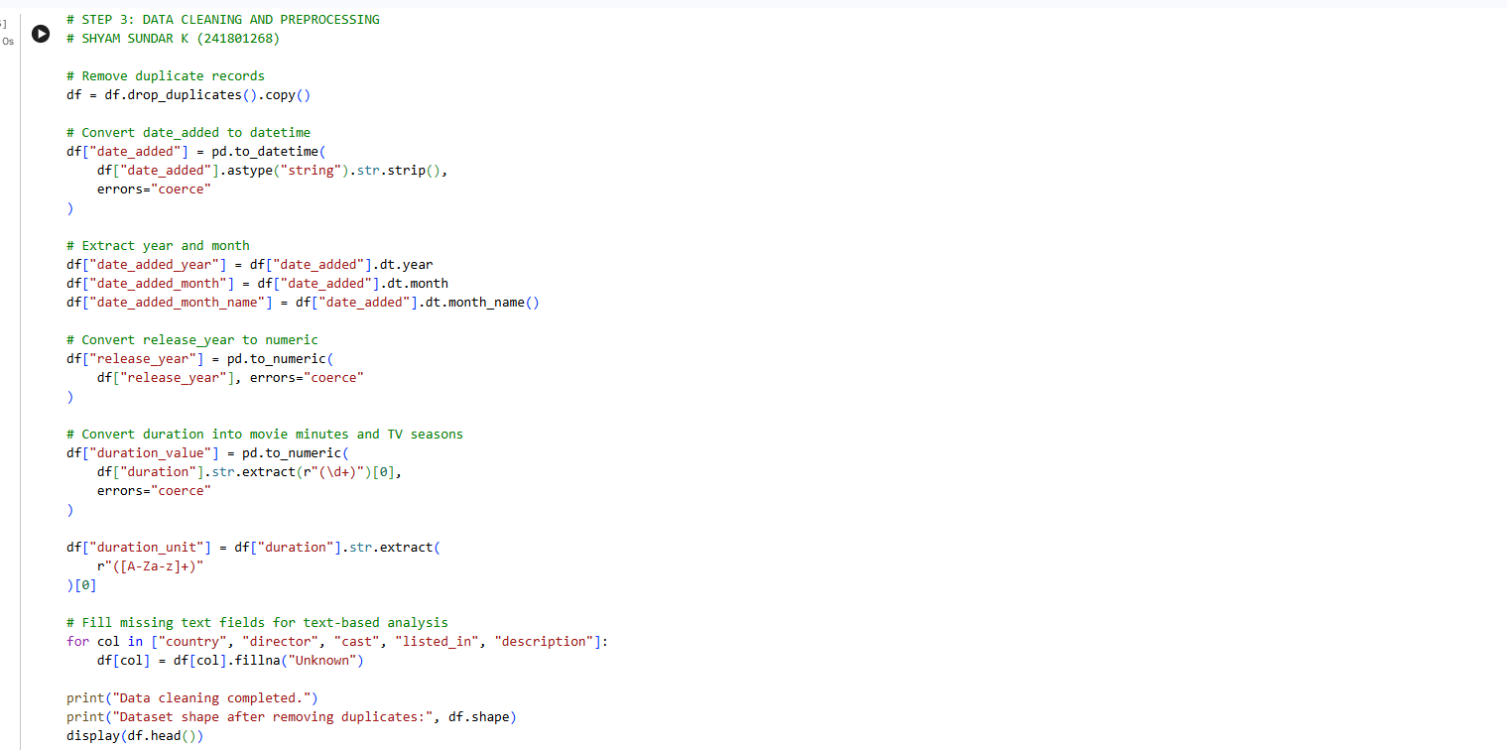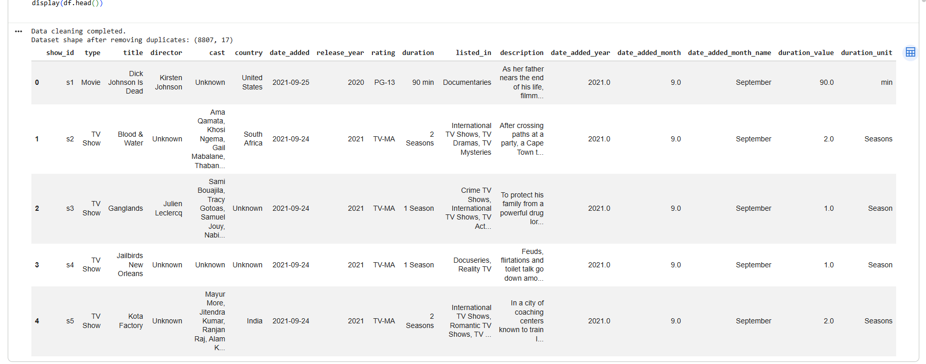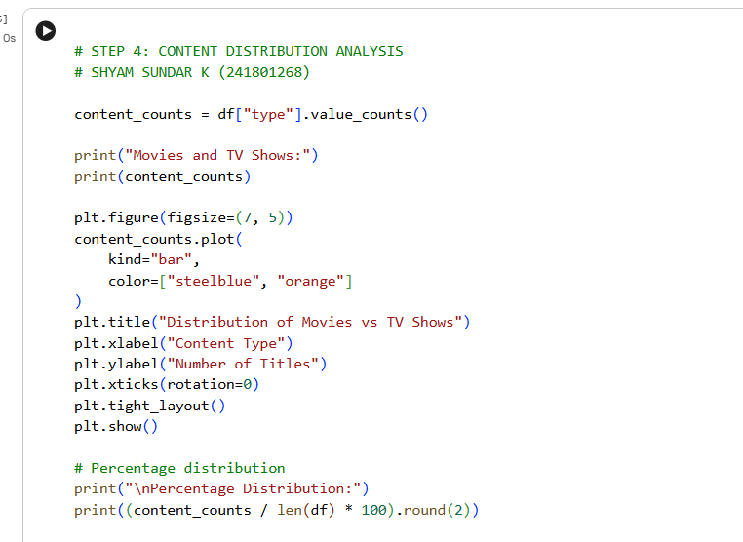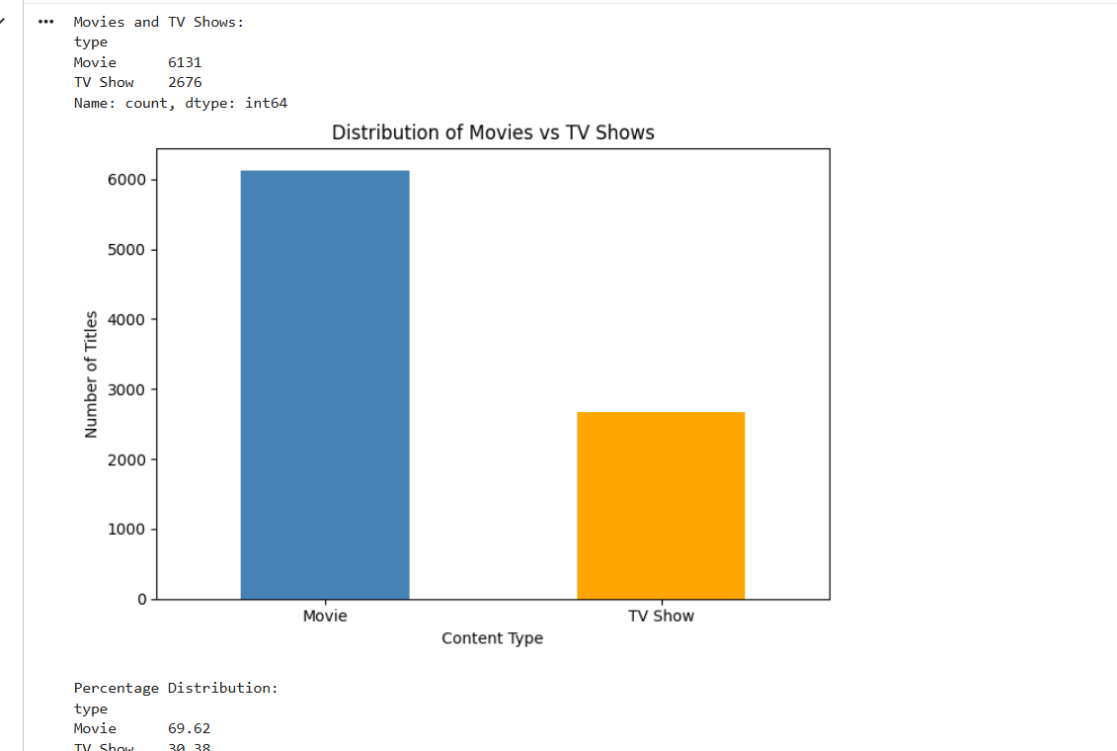
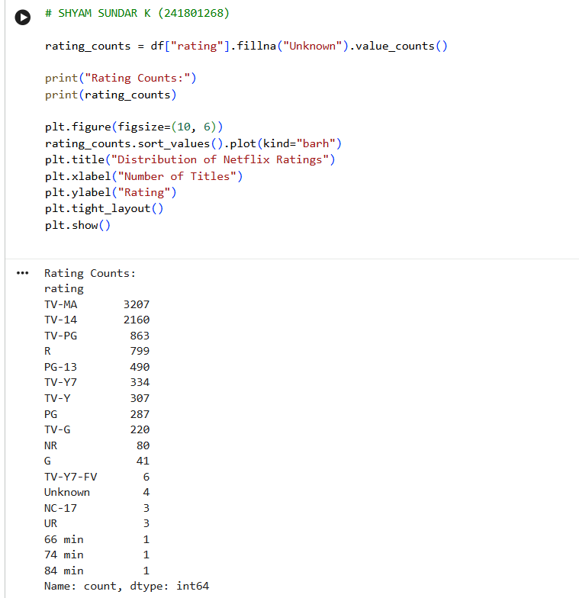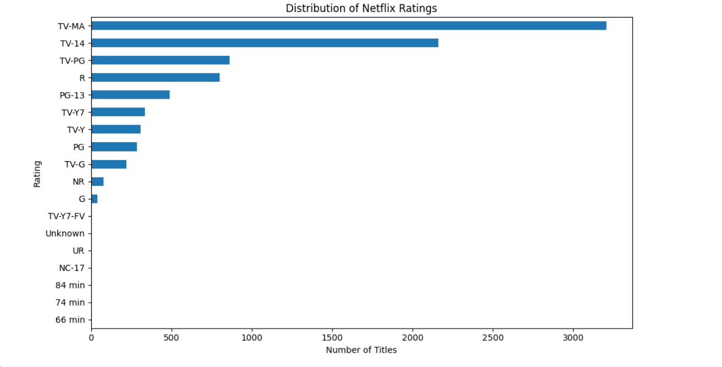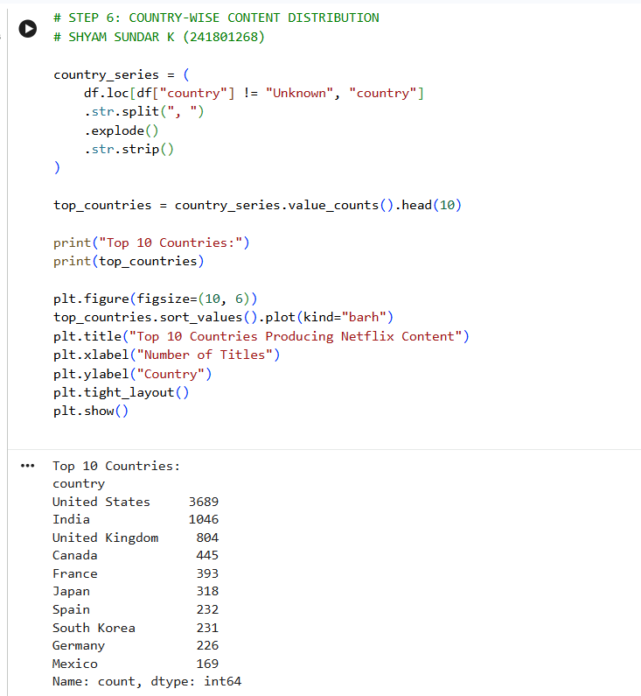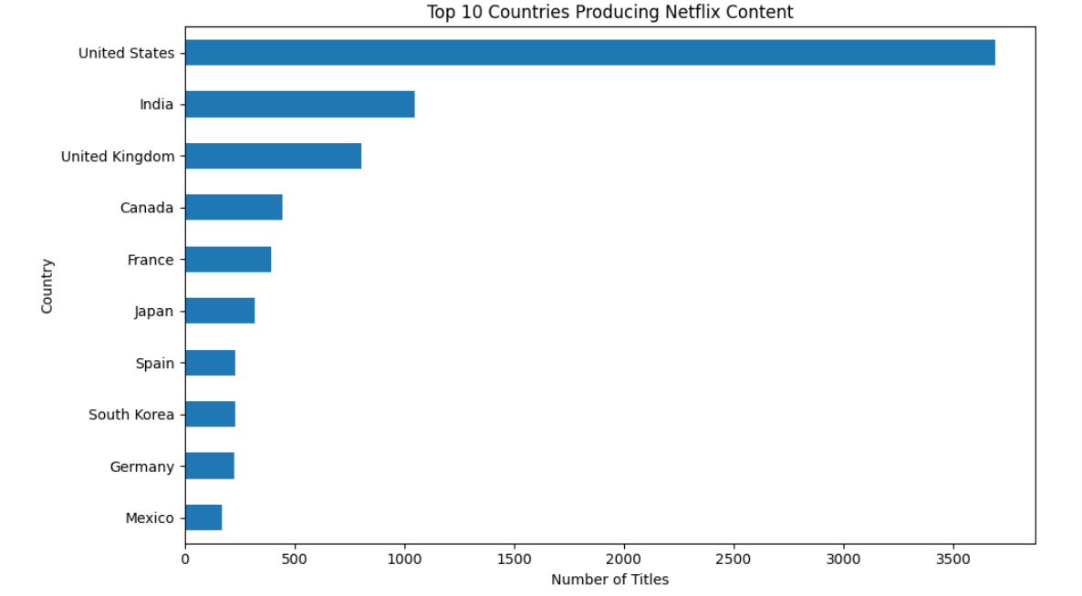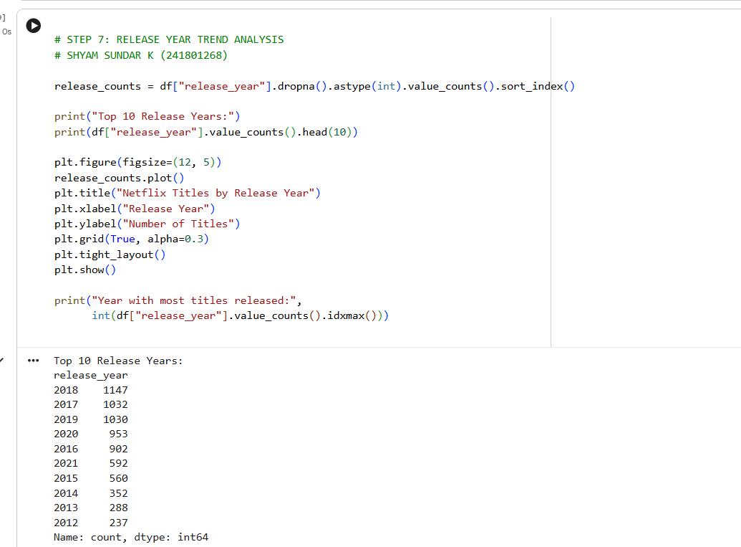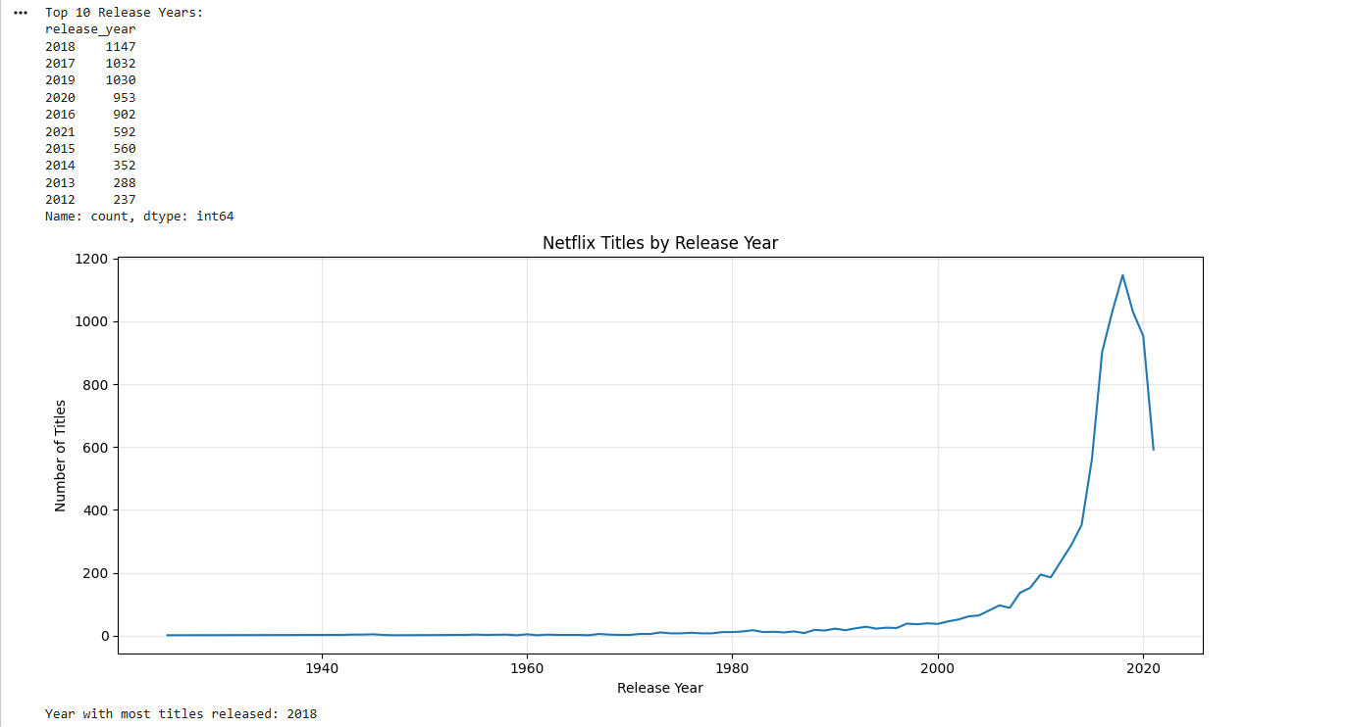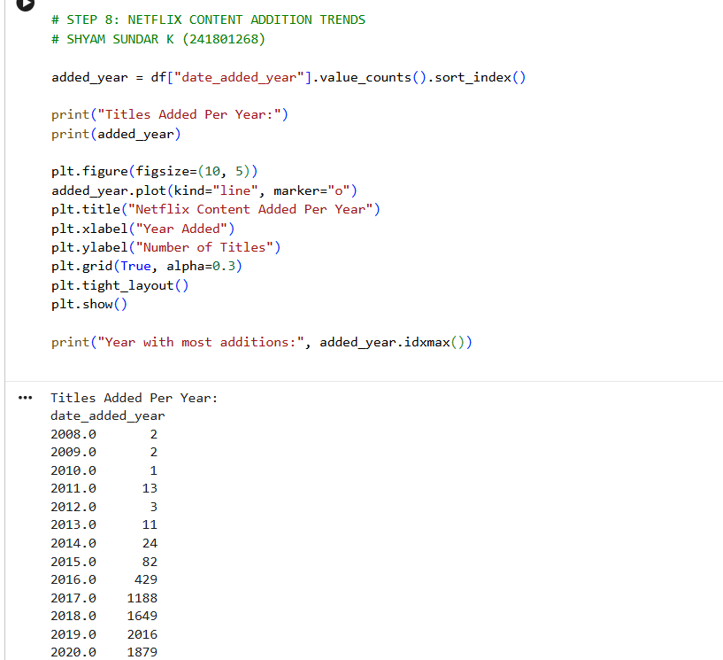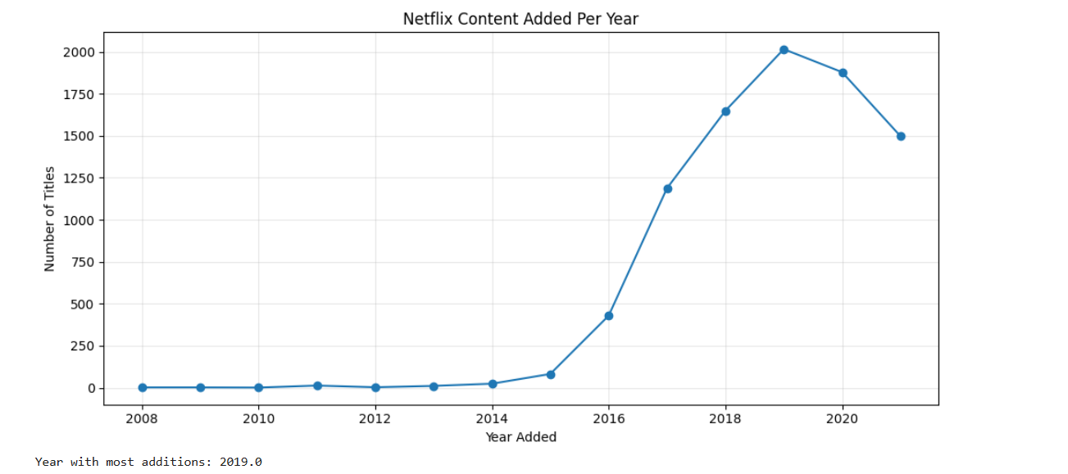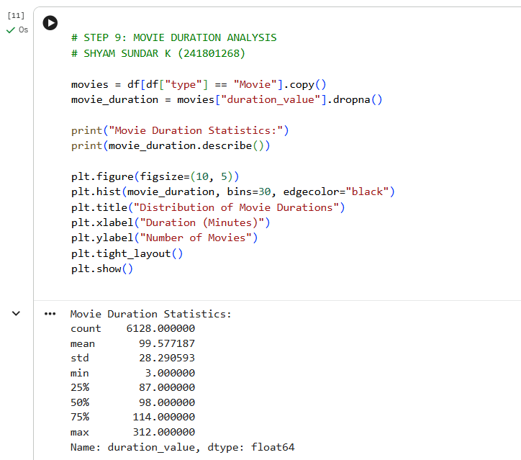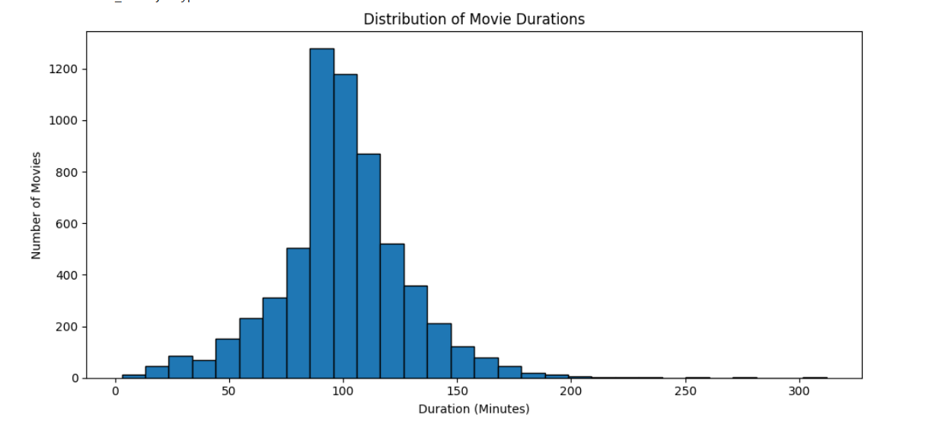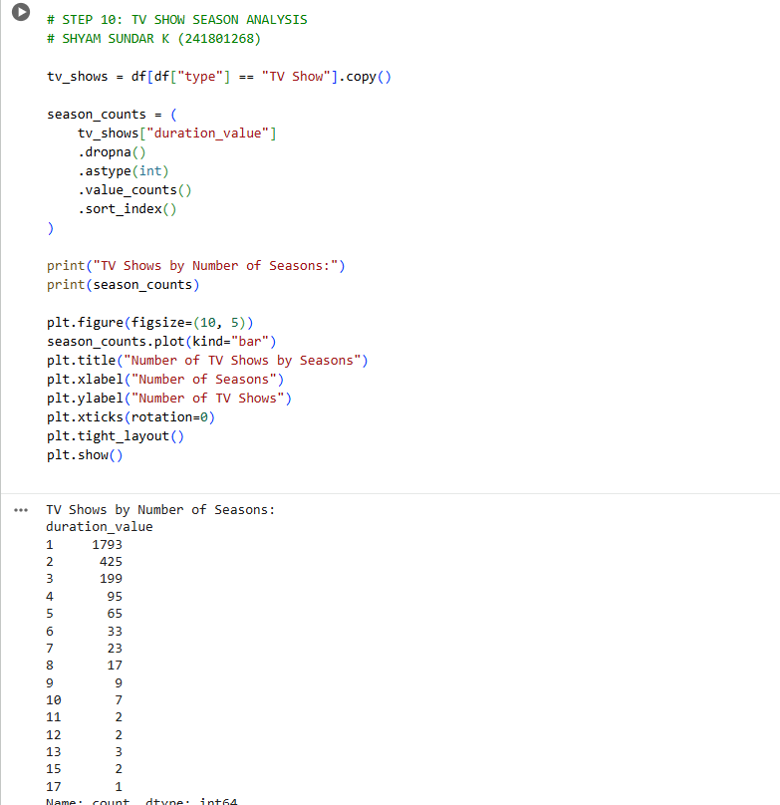
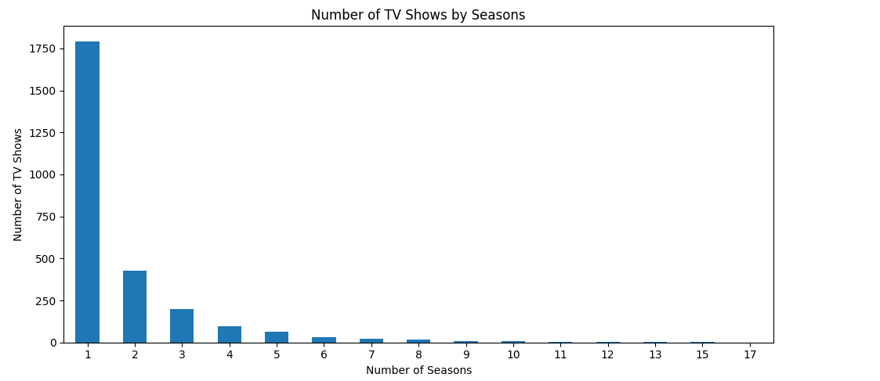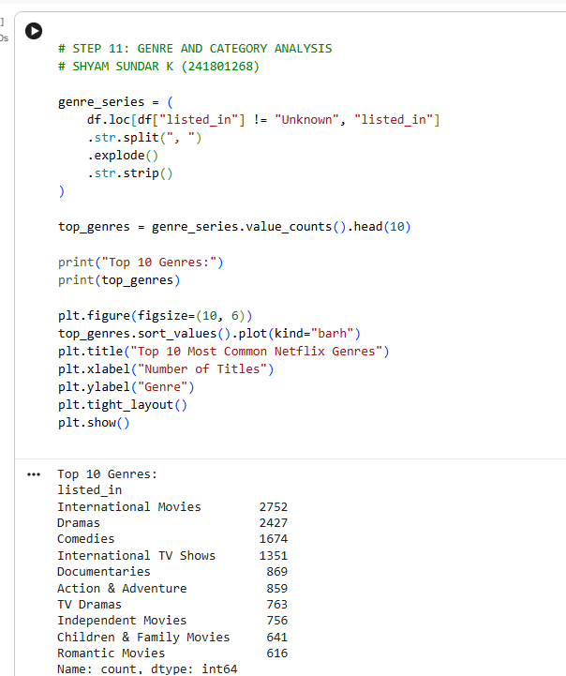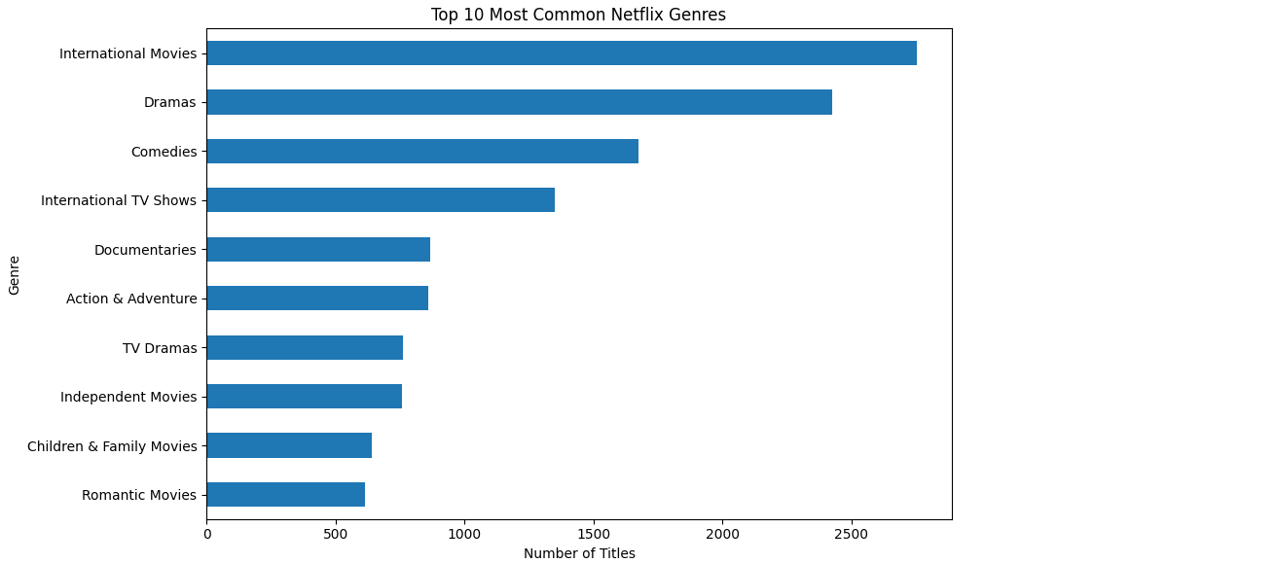
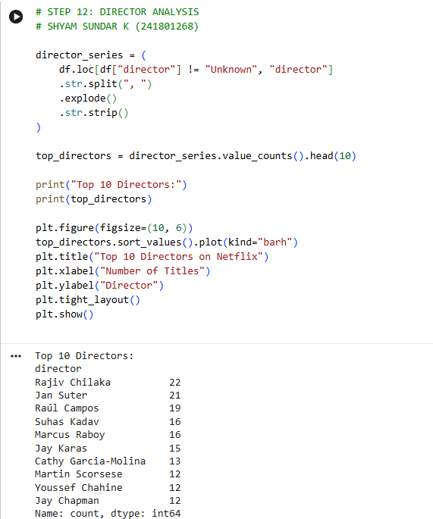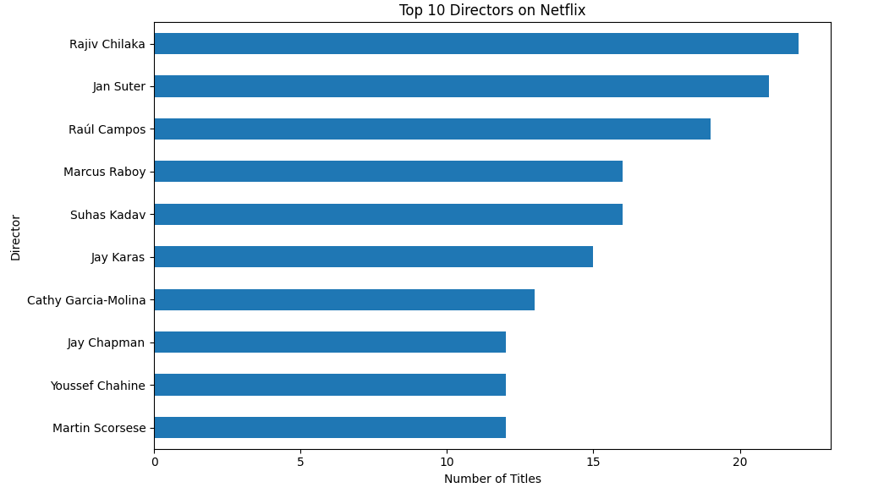
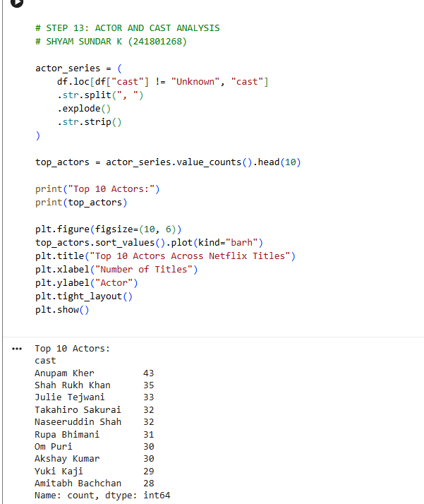
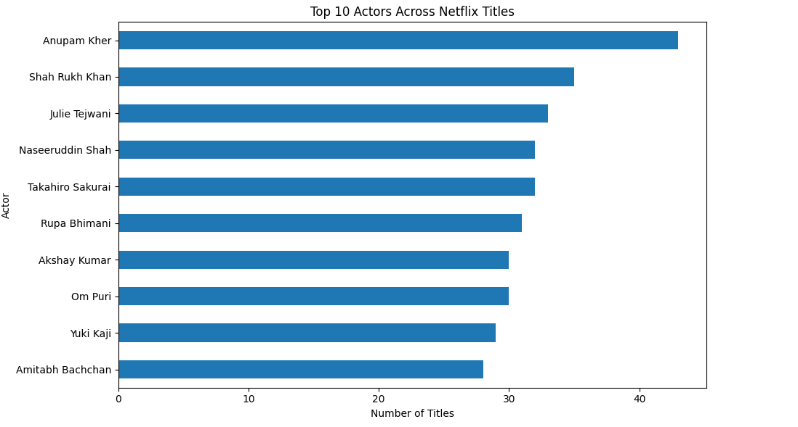
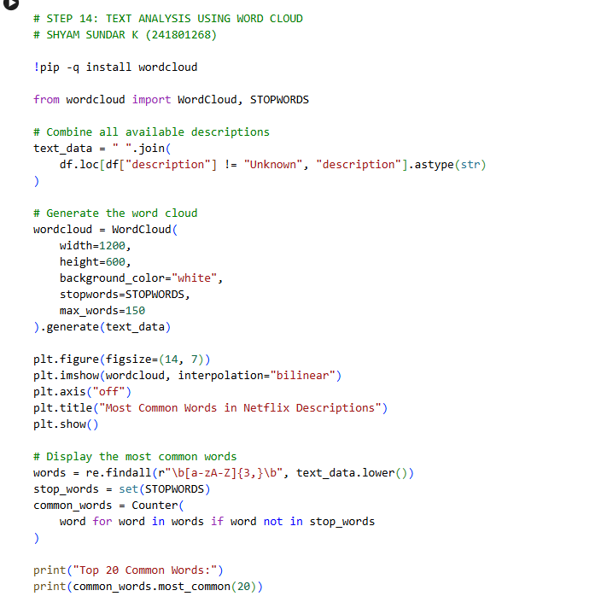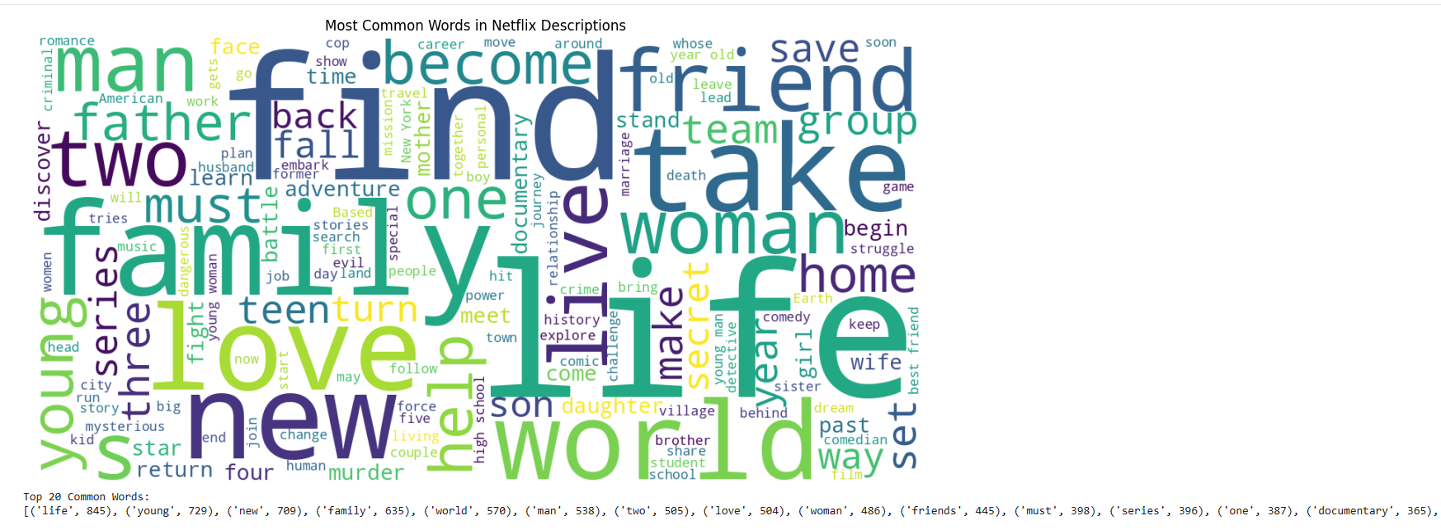
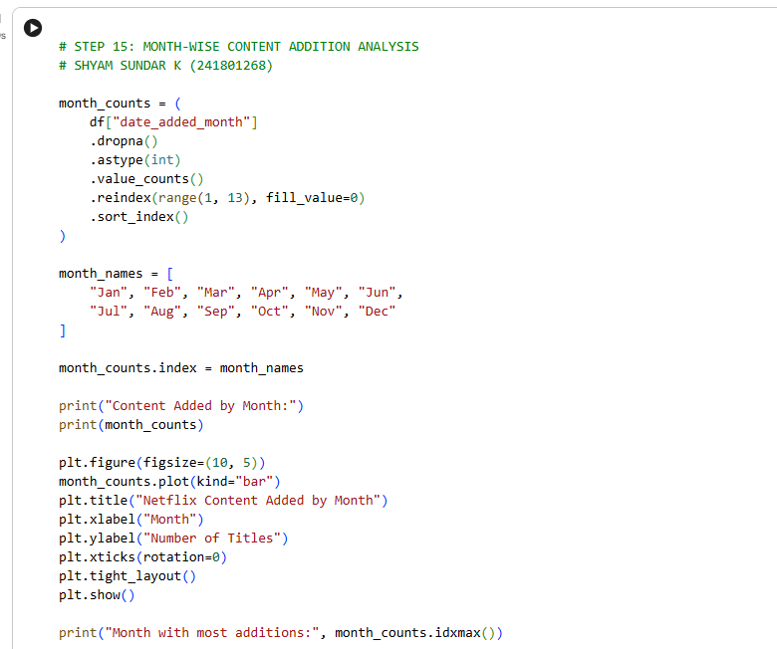
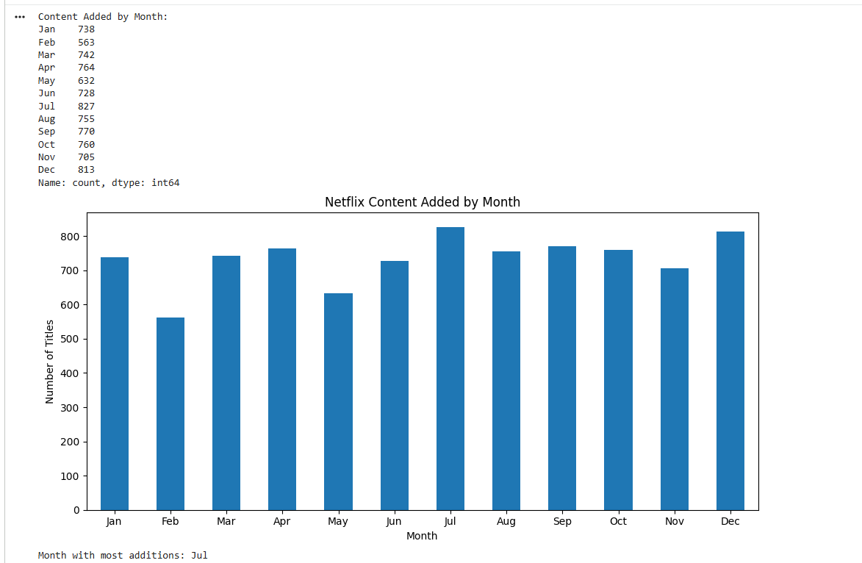
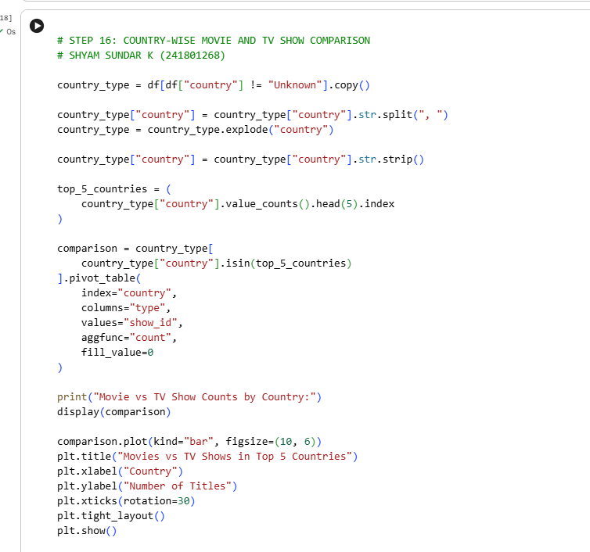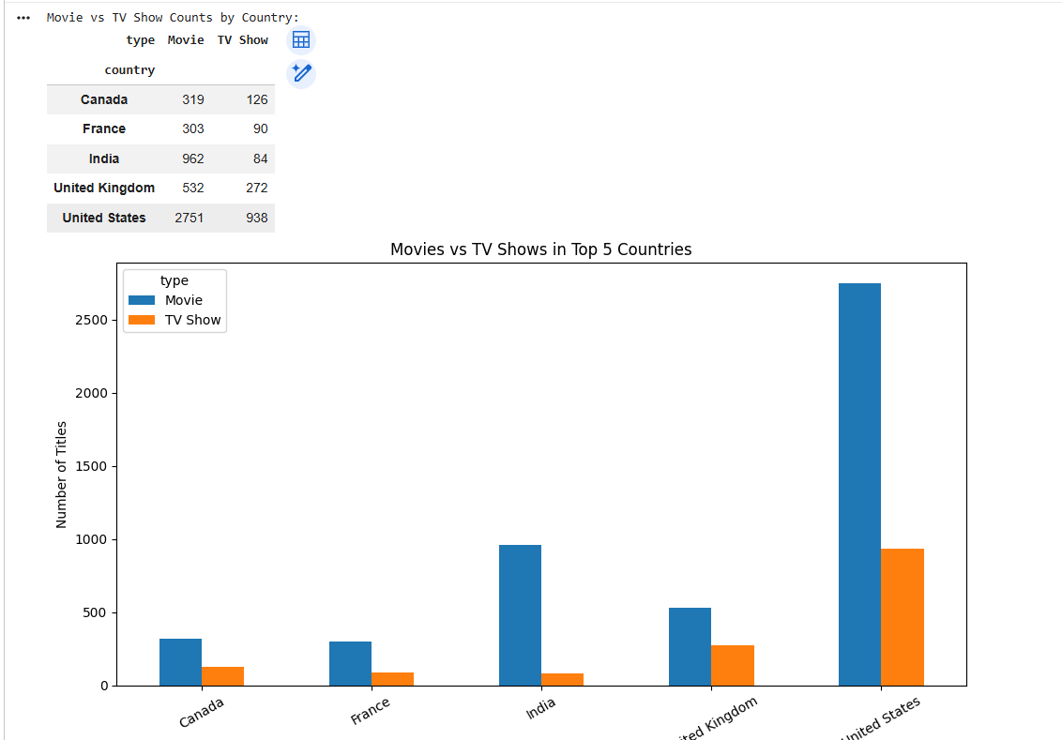

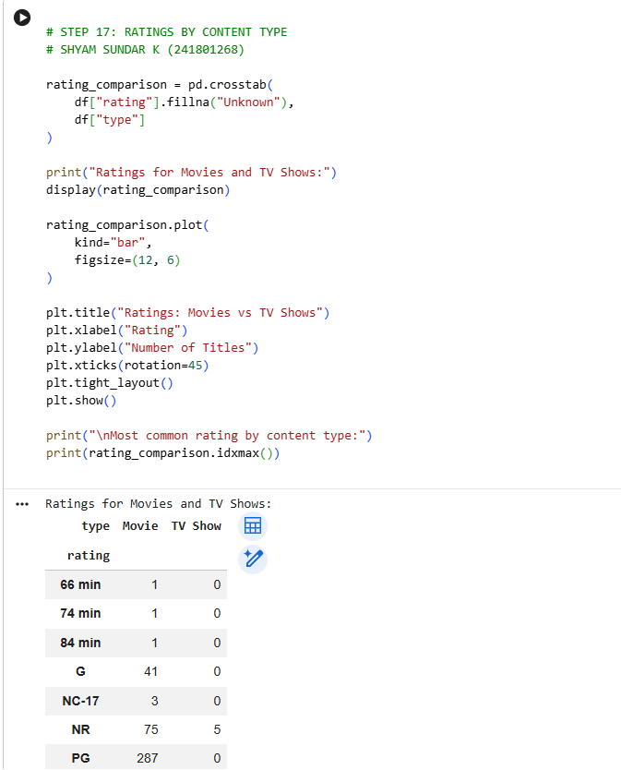
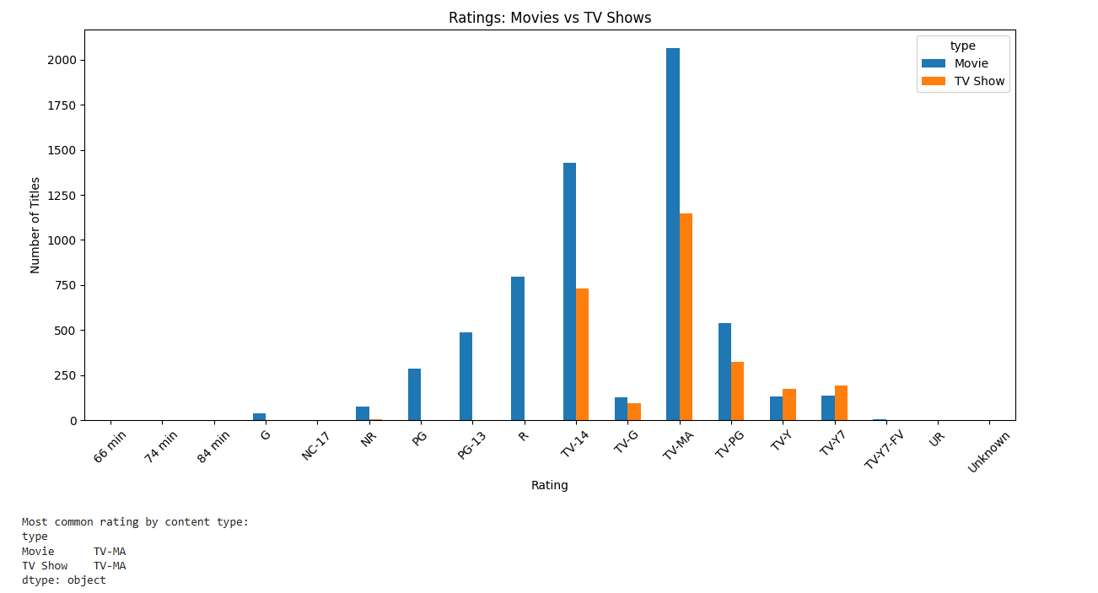
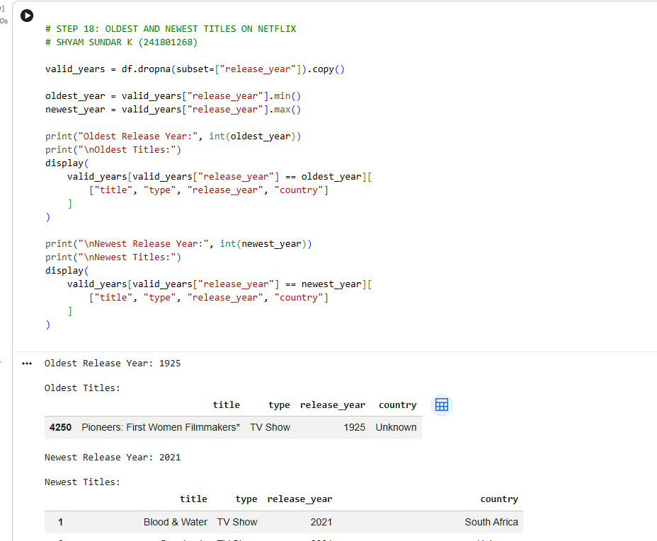

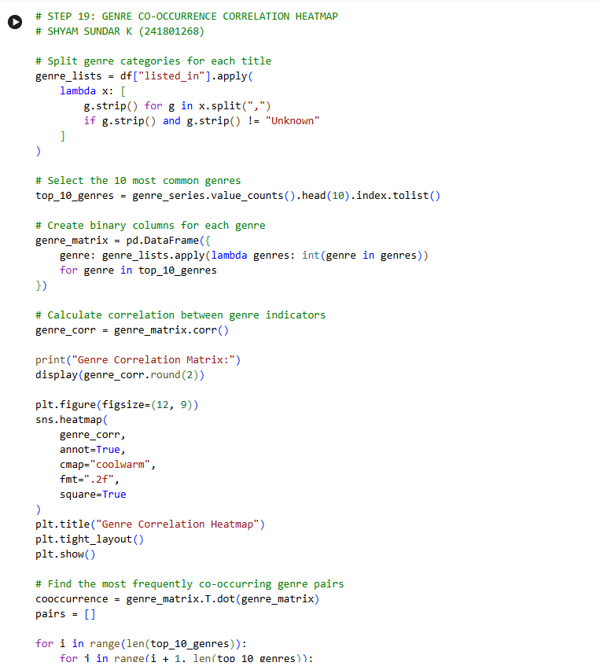
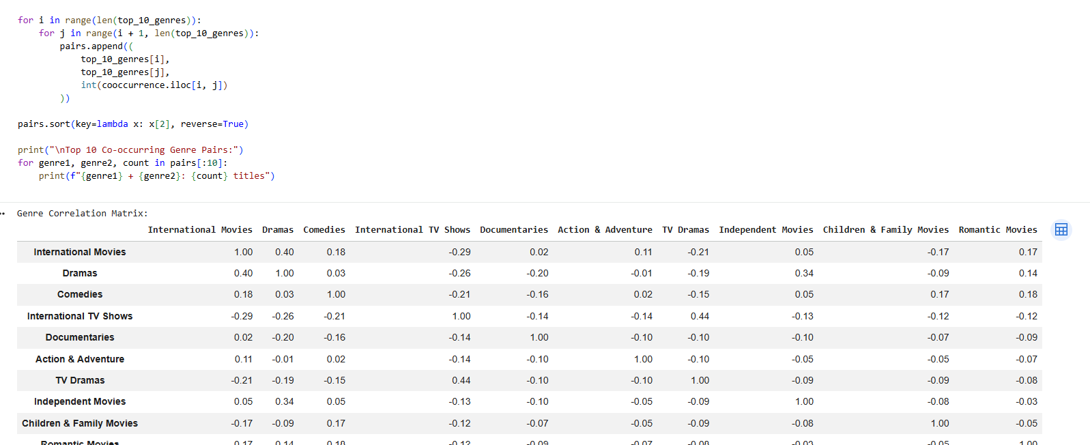

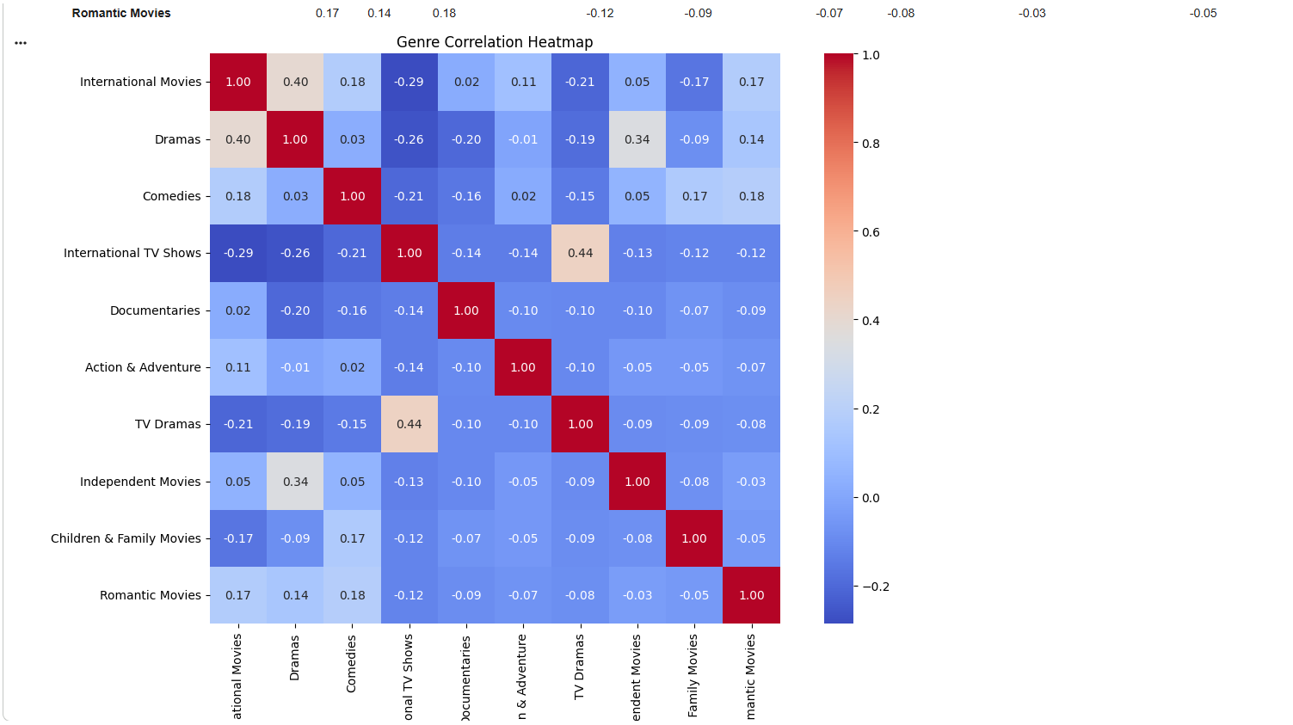
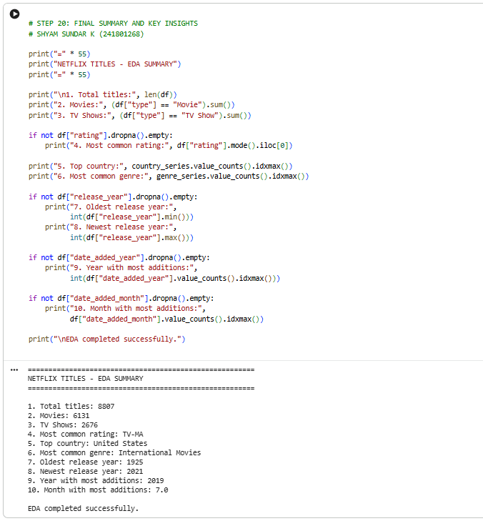

RESULT:
Thus, Exploratory Data Analysis was successfully performed on the Netflix Titles dataset using Python. The distribution of movies and TV shows, ratings, countries, release years, durations, genres, directors, and actors was analyzed. Visualizations such as count plots, histograms, bar charts, a word cloud, and a genre co-occurrence heatmap were generated to identify content distribution patterns, trends, and relationships in the dataset.

